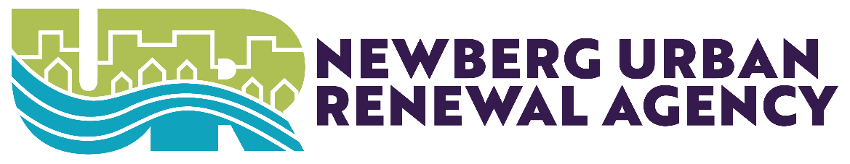
Newberg Urban Renewal Agency
June 2, 2025
Immediately Following Council Meeting
Newberg Public Safety Building 401 E. Third Street
Denise Bacon Community Room
Online: https://us06web.zoom.us/j/89536547180
Public Comment Registration: https://bit.ly/nbgcomment

- CALL TO ORDER
- ROLL CALL
- COMMITTEE BUSINESS
  - NURA Budget Adoption
ADJOURNMENT
ADA STATEMENT
Contact the City Recorder’s Office for physical or language accommodations at least 2 business days before the meeting. Call (503) 537-1283 or email cityrecorder@newbergoregon.gov. For TTY services please dial 711.
*indicates supplementary item

